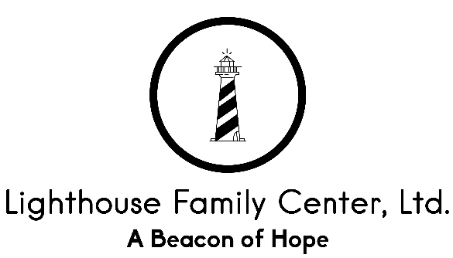

Behavioral Support and Management

Lighthouse Family Center, Ltd specifically prohibits the use of restrictive behavioral support and management interventions. Lighthouse Family Center, Ltd advocates the use of non-physical methods of de-escalation when needed, and supports staff training toward the recognition and implementation of these techniques.

All Lighthouse Family Center, Ltd clients and / or their guardians may receive a copy of our entire behavioral support and management policy upon request. All members of the Lighthouse Family Center, Ltd staff undergo training in order to make sure that all of our staff members know specific ways to help a client whose behavior is becoming out of control. At Lighthouse Family Center Ltd, we know that many of our clients have stressful life situations and difficult past histories. Our attitude makes a big difference toward helping a person stay in control of their feelings and actions.

If a crisis arises, Lighthouse Family Center, Ltd staff members are trained to use a number of methods to help clients feel safe and to prevent further increases in unsafe behaviors. Here are a few:

- We will simply listen calmly and openly. We will not interrupt!

- We will try to refocus attention on a different option, and will attempt to problem-solve.

- We will try to refocus on something positive. We recognize that people who are very angry often feel very sad and helpless.

- We will try to motivate the person to stay in control. This is especially useful with children. Young children might receive praise for keeping control.

- We will try to understand what the person might be going through, and might make statements to let him/her know that we understand. We might ask the person to help us understand better.

Lighthouse Family Center, Ltd wants clients and staff to feel safe and to be safe in our offices. We hope that this explains the ways in which Lighthouse Family Center, Ltd staff will help clients whose upset feelings may become extreme.

I have been offered a copy of the Lighthouse Family Center LTD Service Philosophy regarding behavioral support and management. I am aware that I can ask for a copy of this policy and training program at any time.

___________________________________________ _____________
Client / Guardian Signature Date
______________________________________ ____________
Lighthouse Family Center LTD Staff Member Date

